Sir Syed University of Engineering and Technology

CE-301L Database Management System Lab

Project Report
(Disaster Management System)
Group Members Name | Roll Number
M.Umer Shaikh | 2022F – BCE – 209
Sabih asad | 2022F – BCE – 037
Bilal ahmed khan | 2022F – BCE – 035
Syed Hashir Hashmi | 2022F – BCE – 030

Submitted To
Miss Faiza Farooq

Computer Engineering Department
Sir Syed University of Engineering and Technology University Road Karachi - 75300 http://www.ssuet.edu.pk

TABLE OF CONTENT

S.No | Content | Pg No
 | Acknowledgment | 3
 | Abstract | 4
 | Introduction | 5
 | Methodology | 6
a. | Database Schema | 7
b. | Entity Relationship Diagram | 8
c. | Normalization | 9-11
d. | Theoretical Description | 12
 | Results | 13-18
 | Conclusion | 19

ACKNOWLEDGEMENT

It is our foremost duty to express our deep regards and gratitude to our Database Management System Lab Miss,
(Ms. Faiza Farooq)
under whom guidance and supervision, we were able to undertake this project. We have taken efforts in this project. However, it would not have been possible without the kind support and help of our many individuals. I would like to extend my sincere thanks to all of them. It has been great honor and privilege to undergo training. I am highly indebted to our teacher for her guidance and constant supervision as well as for providing necessary information regarding the project and also for her support in completing the project. Her constant guidance and willingness to share her vast knowledge made us understand this project and its manifestations in great depths helped us to complete the assigned tasks on time.

Abstract
The Disaster Management System (DMS) is an advanced digital platform designed to streamline relief operations during emergencies. By integrating victim tracking, volunteer coordination, donation management, resource monitoring, and disaster zone updates, the system enables efficient and timely disaster response. This report provides a comprehensive overview of the system's design, implementation, and benefits.

Introduction
The Disaster Management System is a comprehensive digital platform designed to streamline the coordination of relief efforts during emergencies. It provides a centralized solution for efficiently managing critical aspects, such as tracking victims, volunteers, donations, resources, and disaster zones. The system ensures seamless information updates about disaster-affected areas,with accurate and real-time data.
With full CRUD (Create, Read, Update, Delete) operations, users can effectively manage entries for victims, volunteers, donations, and resources. The platform is developed using HTML, CSS, JavaScript, PHP, and SQL for database management, ensuring a responsive and user-friendly interface coupled with a robust backend for reliable data handling.

Methodology
- Database Schema
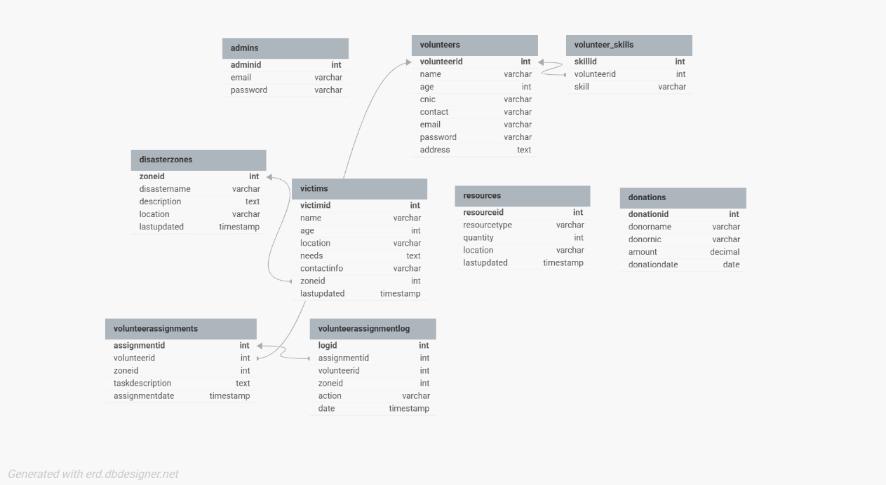

- Entity Relationship Diagram
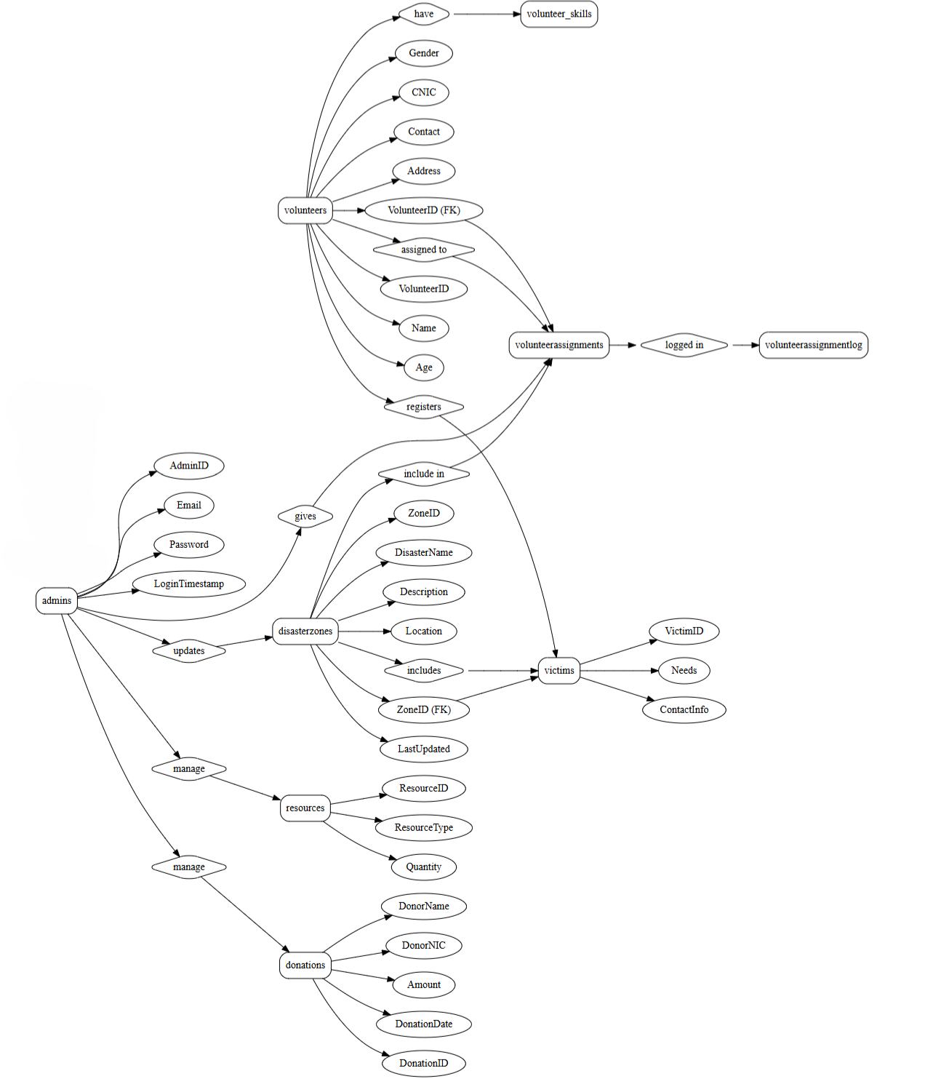
- Normalization
1NF (First Normal Form)
1NF ensures:
- Data is in a tabular format with rows and columns.
- Each cell contains a single, atomic value.
- Each row is uniquely identifiable with a primary key.
Verification:
- All tables have clearly defined primary keys (AdminID, VolunteerID, SkillID, etc.).
- Columns store atomic values (e.g., Name, Email, Age, etc.).
- No repeated groups or multi-valued attributes exist.
2NF (Second Normal Form)
2NF ensures:
- The database is in 1NF.
- There are no partial dependencies. (Non-key attributes must depend on the entire primary key, not a part of it.)
Verification:
- Single Primary Keys: Most tables have a single-column primary key, so no partial dependencies exist.
- Composite Keys: In volunteer_skills, the Skill attribute depends entirely on the composite key (SkillID, VolunteerID).
- Foreign keys reference the primary key of related tables (VolunteerID in volunteer_skills, ZoneID in victims, etc.).
3NF (Third Normal Form)
3NF ensures:
- The database is in 2NF.
- There are no transitive dependencies. (Non-key attributes should not depend on other non-key attributes.)
Verification:
- Admins Table:
  - Email and Password depend directly on AdminID. No transitive dependencies.
- Volunteers Table:
  - Attributes like Name, Age, Gender, Contact, etc., depend directly on VolunteerID. No transitive dependencies.
- Volunteer Skills Table:
  - Skill depends only on the composite key (SkillID, VolunteerID). No transitive dependencies.
- Disaster Zones Table:
  - Attributes (DisasterName, Description, Location) depend directly on ZoneID. No transitive dependencies.
- Victims Table:
  - All attributes, including Name, Age, Location, etc., depend directly on VictimID.

- Resources Table:
  - ResourceType and Quantity depend directly on ResourceID.
- Donations Table:
  - DonorName, DonorNIC, and Amount depend directly on DonationID.
- Volunteer Assignments Table:
  - All attributes depend on AssignmentID.
- Volunteer Assignment Log Table:
  - All attributes depend on LogID.

- Theoretical Description
The DMS centralizes disaster management operations, ensuring that all critical data is accessible to stakeholders in real time. By integrating different queries and database structures, the system prioritizes resource allocation and task assignments based on predefined parameters.

Key Features:

Victim Tracking: volunteer take victim info about their locations, and their needs by filling form.

Volunteer Coordination: Manages volunteer registrations, assignments.

Donation Management: Tracks monetary donations.

Resource Monitoring: Maintains a database of available resources like food, water, medical supplies, and shelters.

Disaster Zone Updates: Provides information about disaster-affected areas.

Results
Disaster updates:
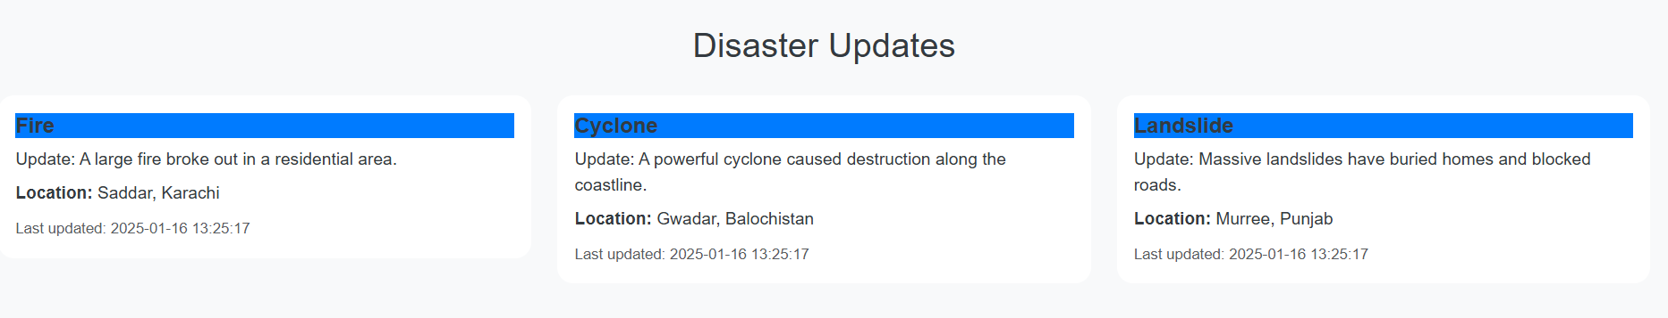
Visual Representation OF no.of victims on each disaster
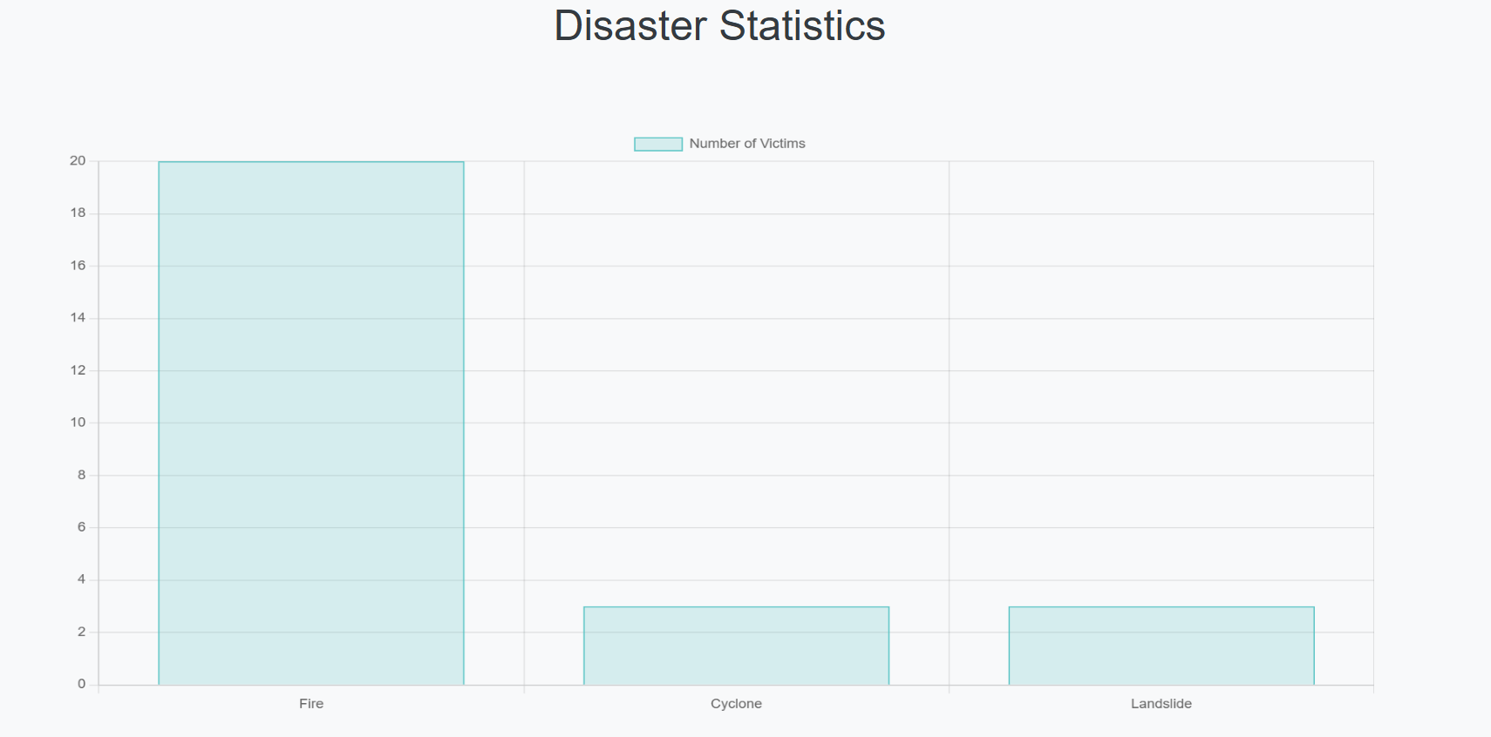

Volunteer signup
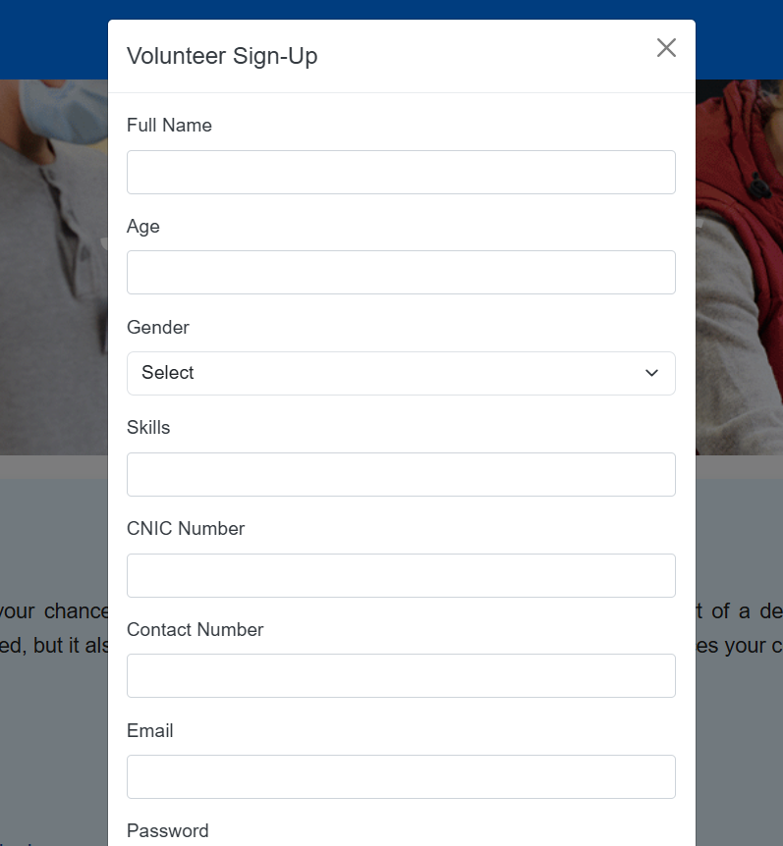
Admin/volunteer login:
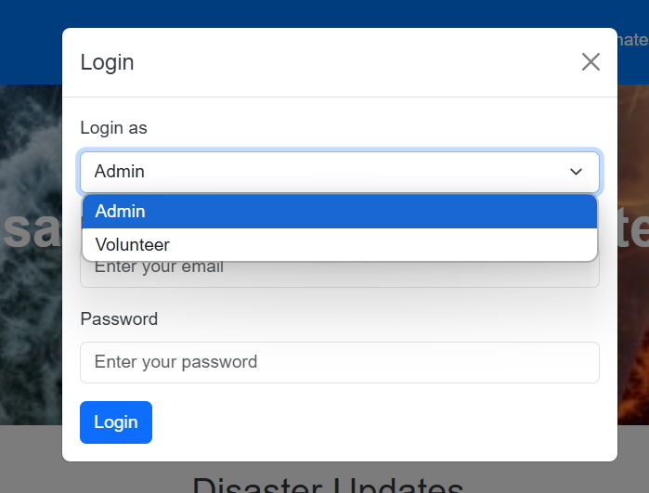
Donation:
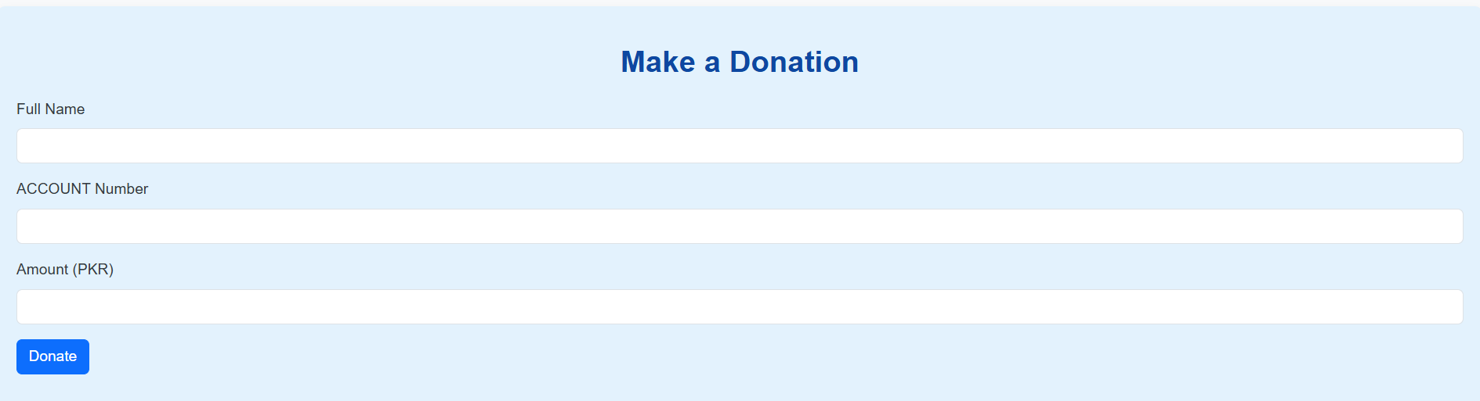
Volunteer Portal:
Avalaible task
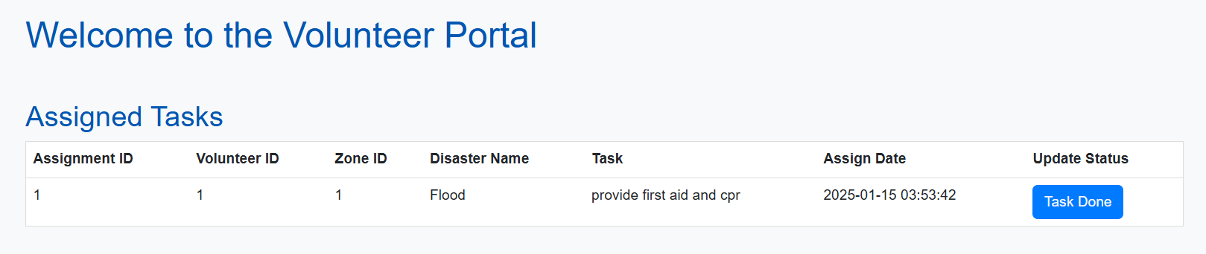

Register victim
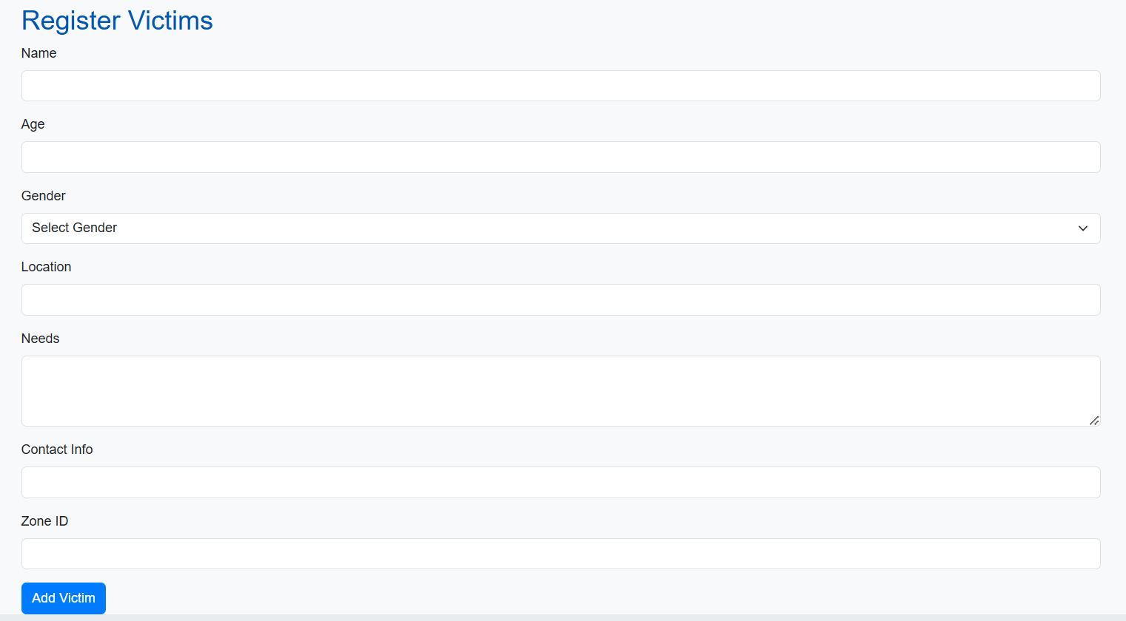
Admin Portal:
Update disaster:
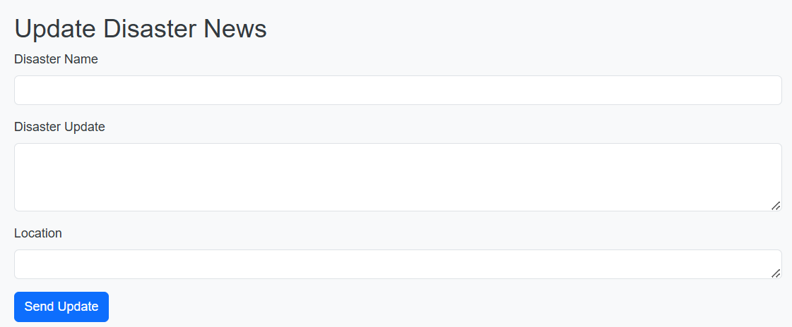

Manage volunteer/assign task
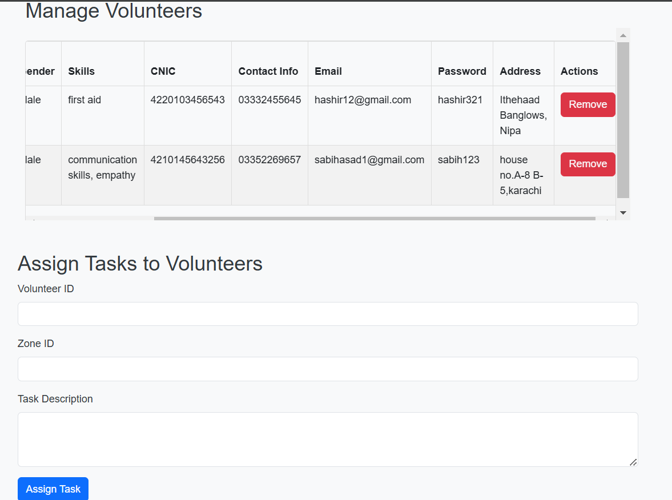
Assignment updates:
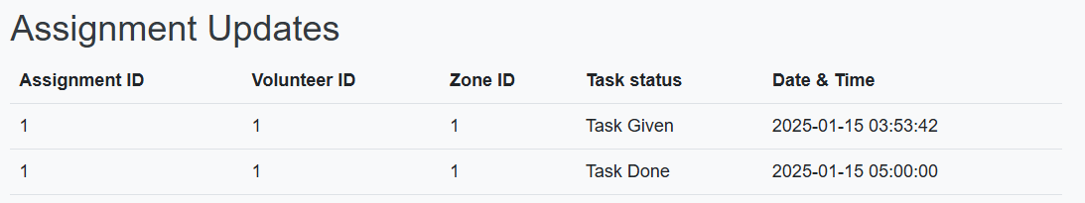

Manage resources:
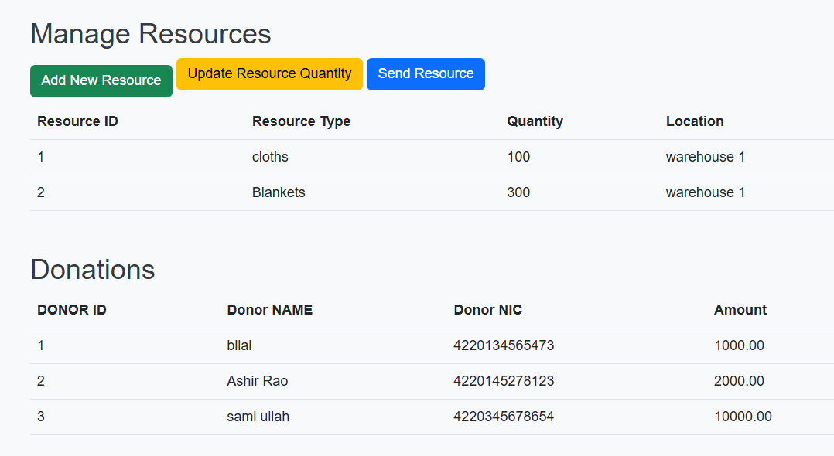

Conclusion
The Disaster Management System is a transformative solution for managing emergency relief operations. By integrating core functionalities into a centralized platform, the system enhances efficiency, and responsiveness. With its modular design the DMS is a critical tool for disaster management agencies, ensuring timely assistance to those in need and reducing the impact of disasters.

